

**PRT 453** [**PROCESS DEVELOPMENT METHODOLOGIES**](https://online.cdu.edu.au/webapps/blackboard/execute/announcement?method=search&context=course_entry&course_id=_41604_1&handle=announcements_entry&mode=view)

**Owner**

Mr. Narendra Vellela

**Team**

Ms. Raj Kiran

Mr. Rakesh Tata

Mr. Soumith Reddy

School of Engineering and IT

Faculty of EHSE

Charles Darwin University

Darwin

**Abstract Pattern**

**Before**

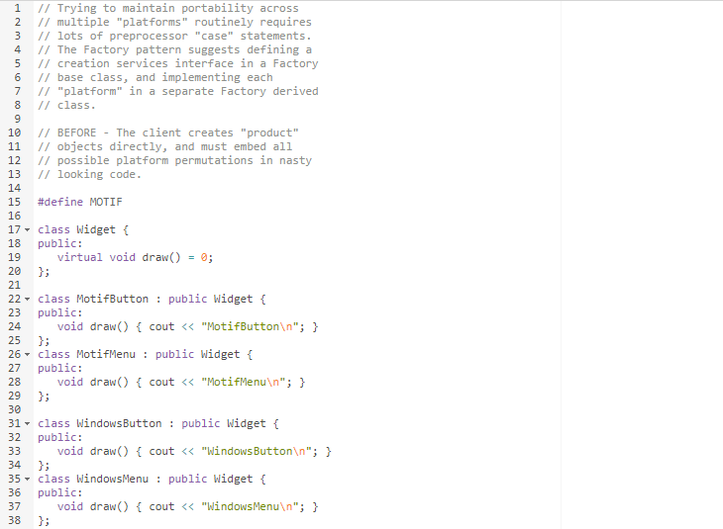

1. Pattern 1

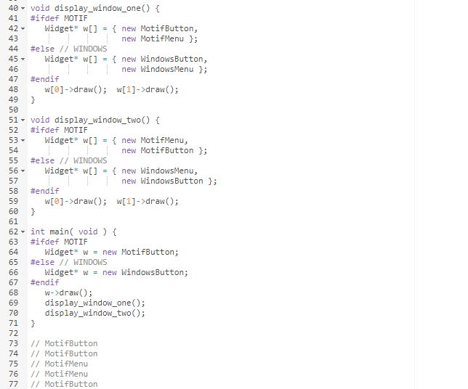

1. Pattern 2

1. Pattern 5

**AFTER:**

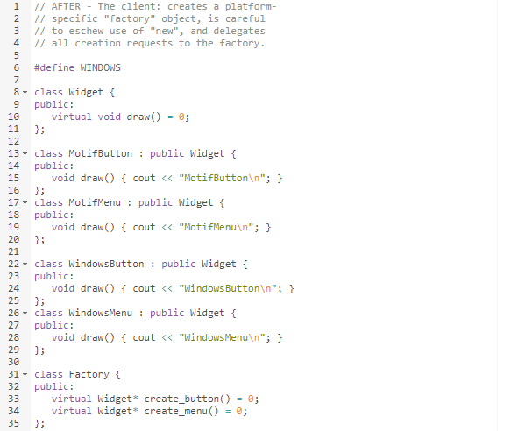

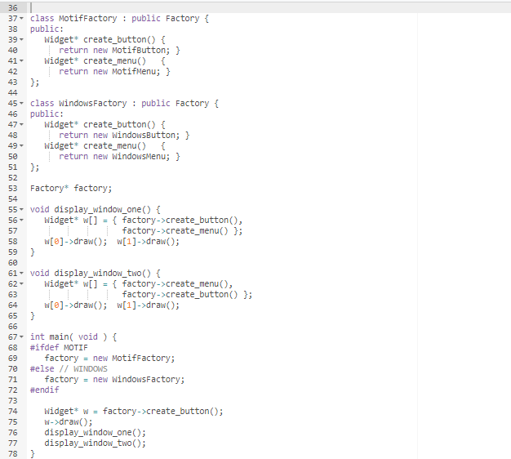

1. After Pattern